Week 11
Majority Element
class Solution {
public int majorityElement(int[] nums) {
int candidate = 0;
int count = 0;
for (int num : nums) {
if (count == 0) {
candidate = num;
}
if (num == candidate) {
count++;
} else {
count--;
}
}
return candidate;
}
}
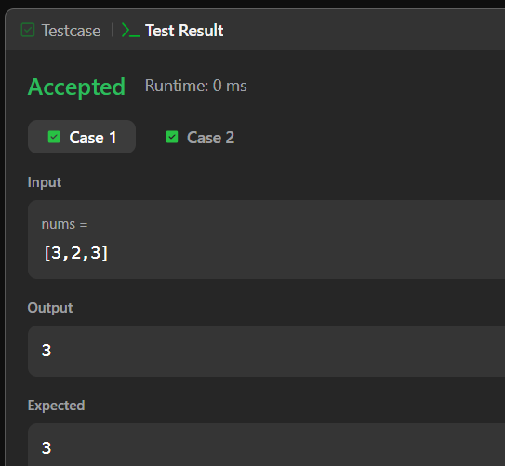
First Unique Character in a String
class Solution {
public int firstUniqChar(String s) {
int[] freq = new int[26];
for (int i = 0; i < s.length(); i++) {
freq[s.charAt(i) - 'a']++;
}
for (int i = 0; i < s.length(); i++) {
if (freq[s.charAt(i) - 'a'] == 1) {
return i;
}
}

return -1;
}
}
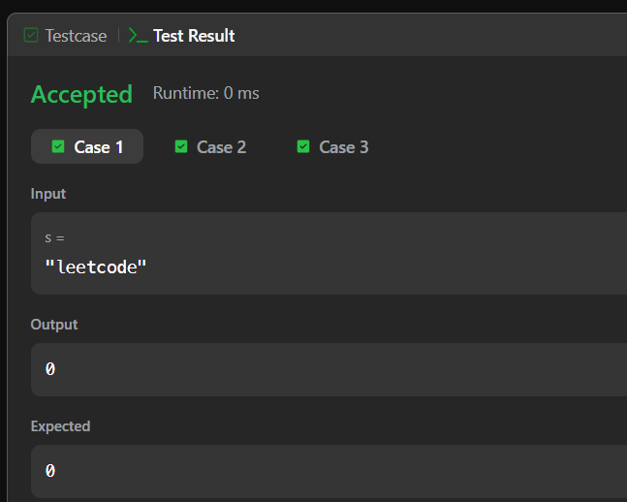
Degree of an Array
import java.util.HashMap;
class Solution {
public int findShortestSubArray(int[] nums) {
HashMap<Integer, Integer> count = new HashMap<>();
HashMap<Integer, Integer> first = new HashMap<>();
HashMap<Integer, Integer> last = new HashMap<>();
int degree = 0;
for (int i = 0; i < nums.length; i++) {
int num = nums[i];
count.put(num, count.getOrDefault(num, 0) + 1);
if (!first.containsKey(num)) {
first.put(num, i);
}
last.put(num, i);
degree = Math.max(degree, count.get(num));
}
int result = nums.length;
for (int num : count.keySet()) {
if (count.get(num) == degree) {
int length = last.get(num) - first.get(num) + 1;
result = Math.min(result, length);
}
}
return result;
}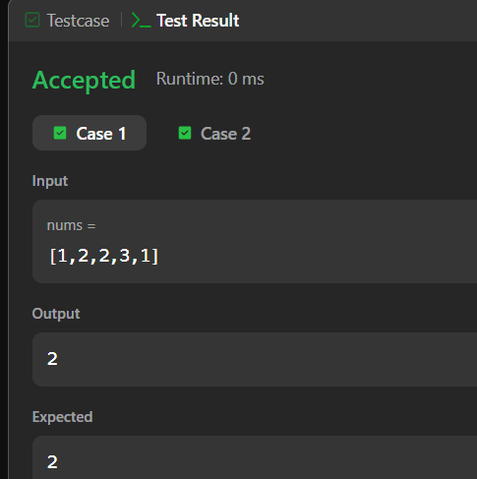
Pascal's Triangle
import java.util.*;
class Solution {
public List<List<Integer>> generate(int numRows) {
List<List<Integer>> result = new ArrayList<>();
for (int i = 0; i < numRows; i++) {
List<Integer> row = new ArrayList<>();
row.add(1);
for (int j = 1; j < i; j++) {
int value = result.get(i - 1).get(j - 1)
+ result.get(i - 1).get(j);
row.add(value);
}
if (i > 0) {
row.add(1);
}

result.add(row);
}

return result;
}
}
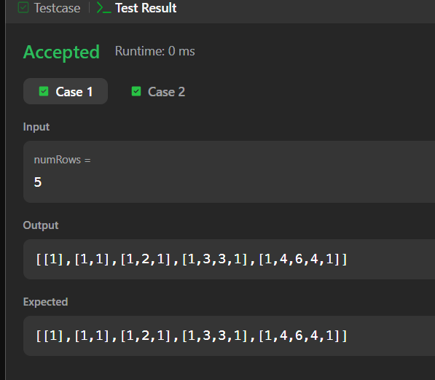
Two Sum
import java.util.HashMap;
class Solution {
public int[] twoSum(int[] nums, int target) {
HashMap<Integer, Integer> map = new HashMap<>();
for (int i = 0; i < nums.length; i++) {
int complement = target - nums[i];
if (map.containsKey(complement)) {
return new int[] { map.get(complement), i };
}
map.put(nums[i], i);
}
return new int[] {};
}
}
